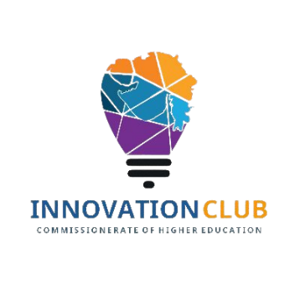
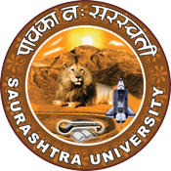
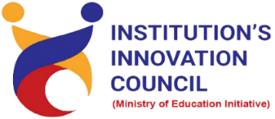

Celebration of National Education Day
“Importance of education in India’s growth”

11th November 2022
At
Department of Chemistry
Saurashtra University Campus, Rajkot
Contents
Saurashtra University – IIC 2
Event Schedule 2
Event Registration Link 2
Brief about Event 3
Key Points 3
Outcome 4
About the Speaker/Chief Guest 5
Connect Us: 7

Saurashtra University – IIC
The university is dedicated to instruction, research, and extending knowledge to the public (public service). Ministry of Education (MoE), Govt. of India has established ‘MoE’s Innovation Cell (MIC)’ to systematically foster the culture of Innovation among all Higher Education Institutions (HEIs). The primary mandate of MIC is to encourage, inspire and nurture young students by supporting them to work with new ideas and transform them into prototypes while they are informative years. Saurashtra University is one the Organization that have constituted the IIC to foster the vision of MoE and be a part for the promotion and development of innovation ecosystem.

Event Schedule

Event Registration Link

bit.ly/SUSEC-NEDAY

Brief about Event
SU Start-up And Entrepreneurship Council & IIC Saurashtra University organized one-day Seminar on "Importance of education in India’s growth" for celebration of "National Education Day " on 11th November 2022, Friday at Department of Chemistry. Students and Faculty of Saurashtra University participated and celebrated National Youth enthusiastically.
National Education Day is an annual observance in India to commemorate the birth anniversary of Maulana Abul Kalam Azad, the first education minister of independent India, who served from 15 August 1947 until 2 February 1958. National Education Day of India is celebrated on 11 November every year.
Seminar was conducted by the students of Chemistry Department on National Education Day. The event began with the lamp lighting ceremony by the Head of the Department and other faculty members. The students gave wonderful presentation highlighting the history of Maulana Abul Kalam Azad’s life, his believes in education and his contributions to the society.
The objective of celebrating National Education Day is described as strengthening India's educational institutions. To raise the quality of education. It is also seen as an occasion to remember Maulana Azad's contribution in laying the foundations of the education system in an independent India. To evaluate the country's current performance in the field. It is also seen as an opportunity to improve the current situation of education in India.
Education plays a major role in a nation’s development and is a basic right of every human being. India is the 2nd largest populated country in the world has a literacy rate of around 74 percent. India’s literacy rate continues to rise, however, there are many states in the country with low literacy rates. Since education is so essential for the development and growth of any country, in India, Kerala tops all states with the highest literacy rate of 94% following by Lakshadweep 91.85%, Mizoram 91.33%, and goa with the literacy rate of 88.70%. On the other hand, Bihar has the lowest literacy rate of 61.80% followed by the states Arunachal Pradesh 65.38%, Rajasthan 66.11%, and Jharkhand with a literacy rate of 66.41%. Looking at these literacy rate statistics, it is clear that India has an even greater need for improvement in the education system that was understood by the speaker.

Key Points

During the session, below mentioned points were discussed:
- Why education is important for the development of India
- Factors effecting Education system
- growth of education in India
- The role of education in India’s economic development
- History of National Education Day
- FAQs related to Importance of education in India’s growth

Outcome

As per the event, students understand the importance of education in India’s growth. Also, how to enhance and improvise the quality of education for students in the country was made understood by the speaker with various examples.
The session focused on the importance of education in the development of our country. The education system plays a crucial role in shaping the future of the nation, and it is important to create awareness among students about the value of education.
The session highlighted the significance of celebrating National Education Day, which is observed on November 11 every year to commemorate the birth anniversary of Maulana Abul Kalam Azad, the first Education Minister of independent India. It is an opportunity to acknowledge the contributions of educators and the impact they have on the lives of students.
Students were informed about the ways in which National Education Day can be celebrated. This includes organizing debates, essay competitions, and cultural programs. The aim is to create a sense of enthusiasm and interest in the importance of education among students.
The session emphasized the need for students to appreciate the abundance of educational opportunities available to them and not to underestimate the power of literacy. Education is not just about acquiring knowledge; it is about developing critical thinking skills and a sense of social responsibility.
In conclusion, the session was informative and enlightening, and it helped students understand the importance of education in nation-building. Celebrating National Education Day is a way to honor the contributions of educators and inspire students to pursue their academic goals with dedication and enthusiasm.

About the Speaker/Chief Guest

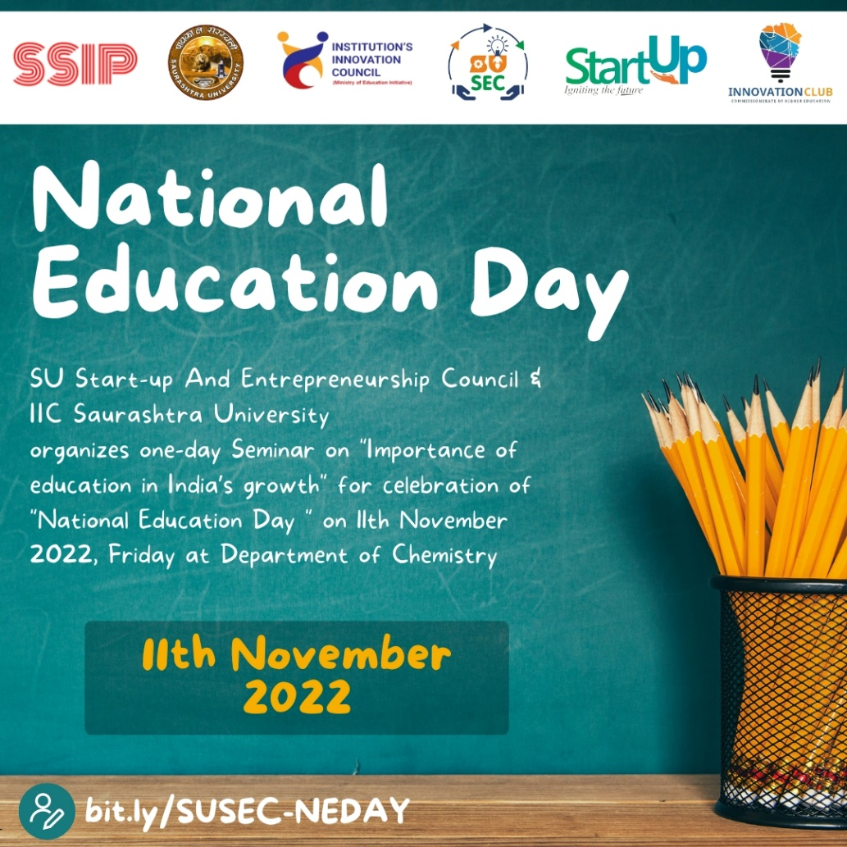

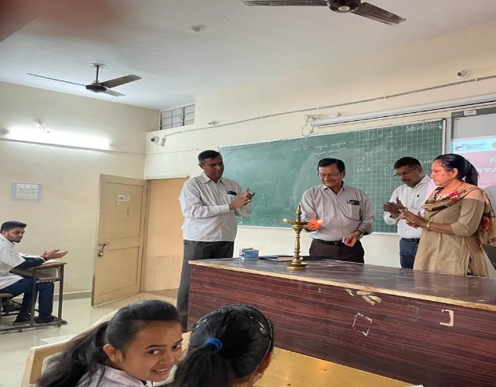
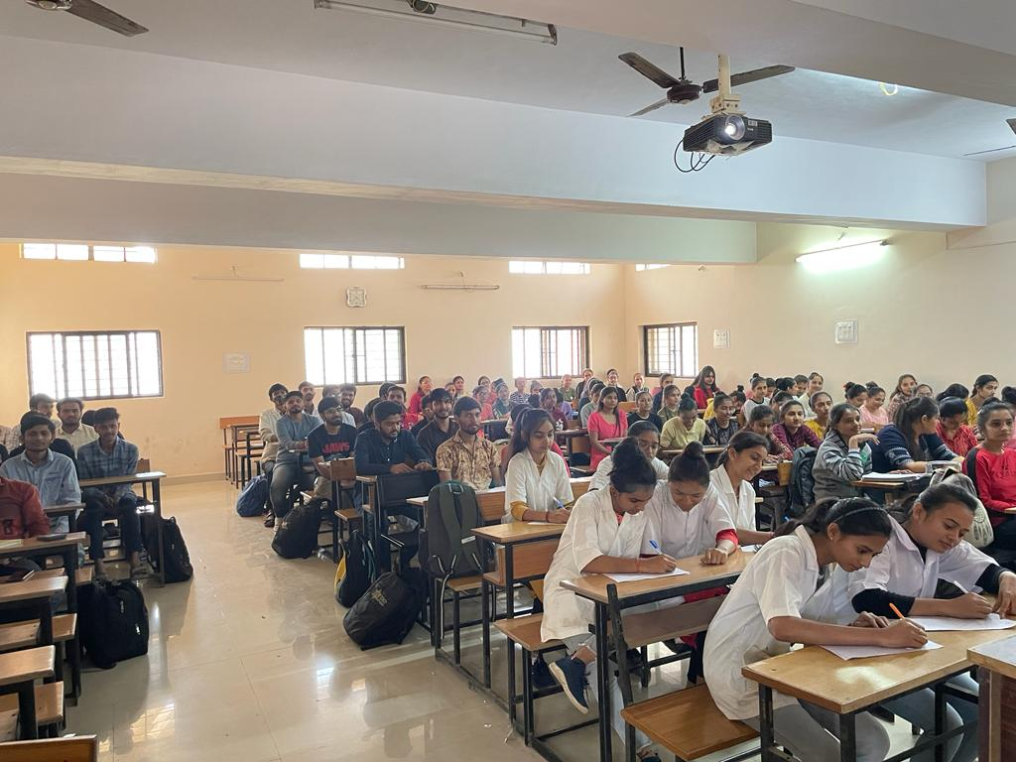
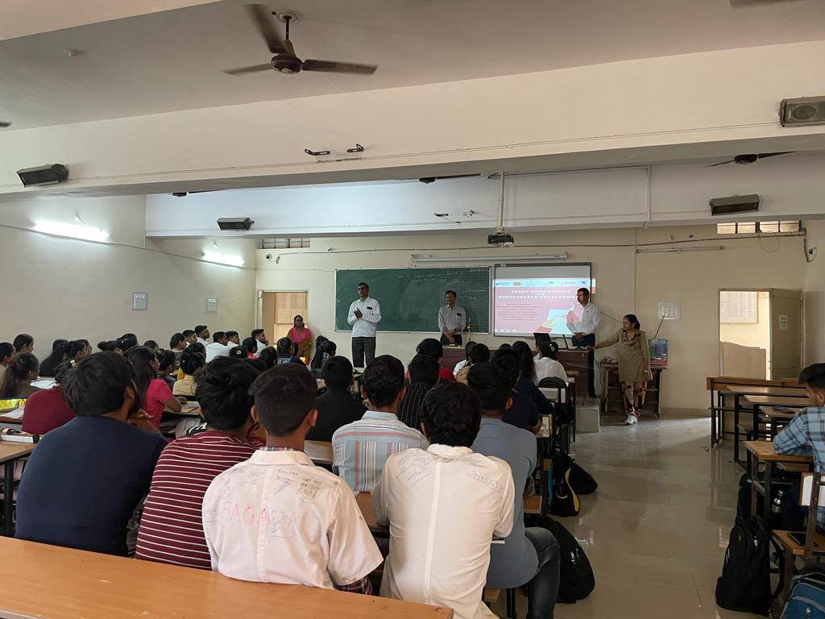

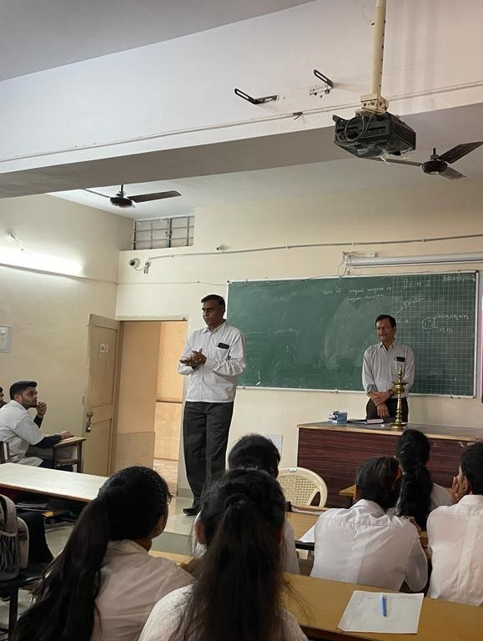
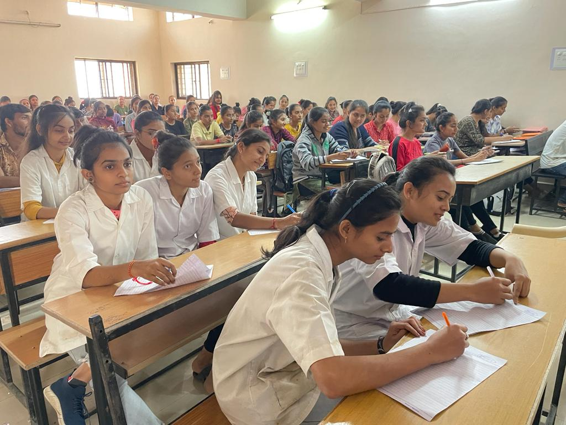

Connect Us:

https://www.linkedin.com/company/susec iic@sauuni.ac.in
https://www.facebook.com/iicsauuni bit.ly/SUSEC-Location
https://www.instagram.com/susecrajkot https://bit.ly/SUSEC-youtube

